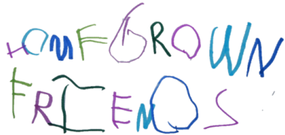

R E G I S T R A T I O N

Class Name(s) and Session(s) _______________________ Cost__________
Name of artist: _______________________________________________
Date of birth:___________________________________ Age___________
Parent or guardian:_____________________________________________
Address:______________________________________________________
Home phone:____________________ Work:_________________________
Mobile:______________________ E-mail:___________________________
Emergency contact:______________________ Phone:_________________
Allergies: YES NO If yes, what _________________________________
Child’s physician:_________________________ Phone:________________
Permission Agreement:
- I/we understand that all Homegrown Friends classes take place at 45 Castlewood Road, West Hartford, CT. I/we grant permission for my/our child to participate in al of the Homegrown Friends activities that take place in the house, with exceptions noted here:

B. I/we grant permission for my/our child to be included in pictures of promotion connected with Homegrown Friends, such as for homegrownfriends.com, Instagram or Facebook.

C. I/we grant permission for the staff of Homegrown Friends to take whatever steps necessary to obtain emergency medical care, if warranted. These steps may include, but are not limited to the following: 1. Administer minor first aid 2. Attempt to contact a person, guardian or emergency contact 3. Attempt to contact childʼs physician 4. Attempt to contact the parent through any of the persons listed above 5. If we cannot contact the parent or the childʼs physician, we will do any of the following: a. Call another physician b. Call an ambulance. c. Have the child taken to the emergency room in the company of a staff member in a staff vehicle. 6. Any expenses incurred under item “5” above will be borne by the childʼs family.

SIGNED: ___________________________________________ DATE : _____________
By signing this form I agree to the policies in this document. Checks are made payable to Meredith Magee Donnelly, 45 Castlewood Road, West Hartford, CT 06107

